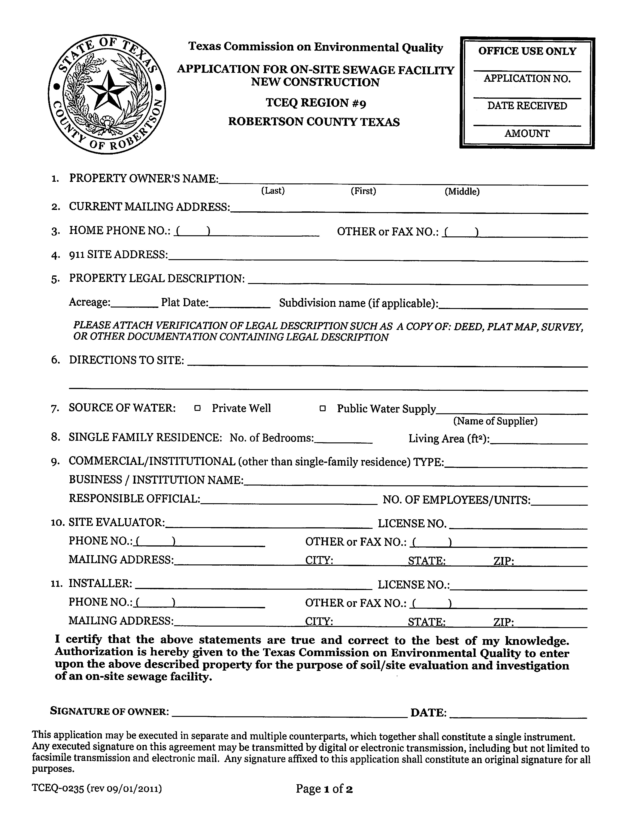

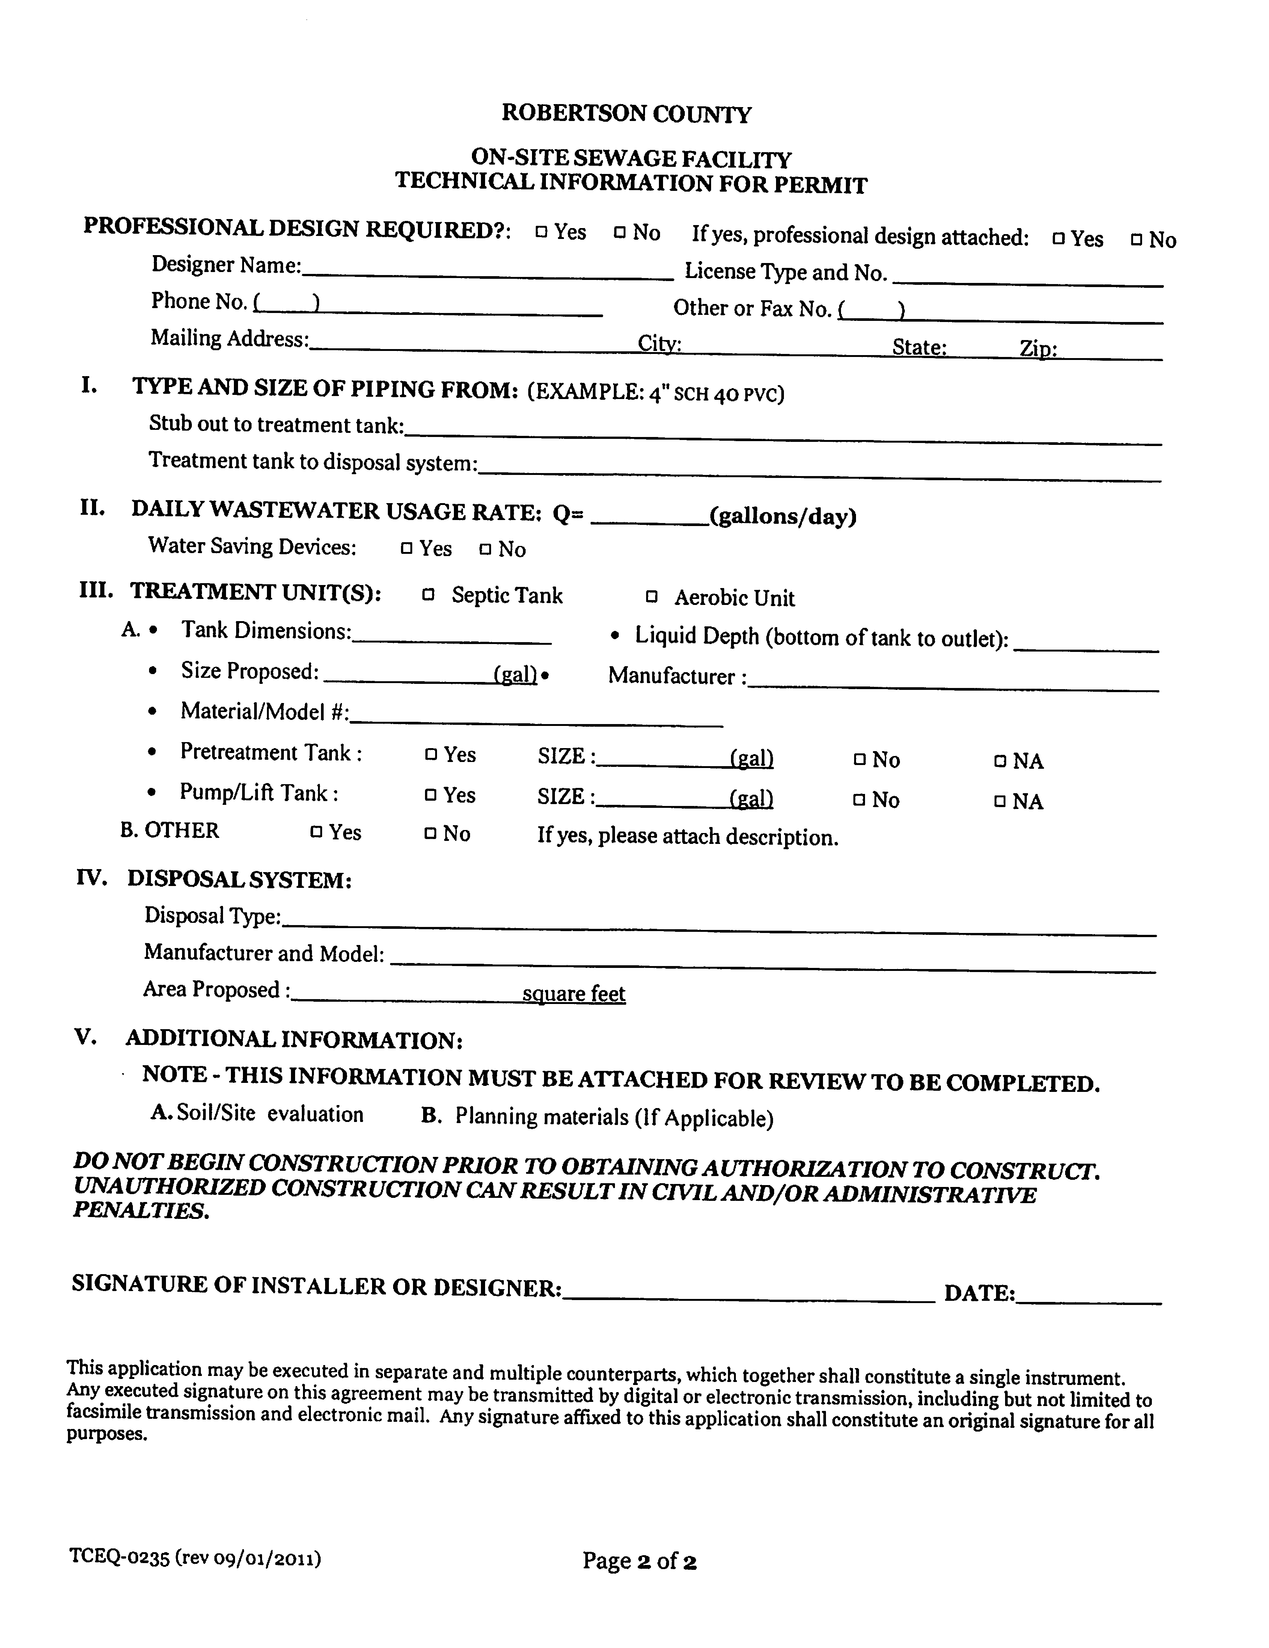

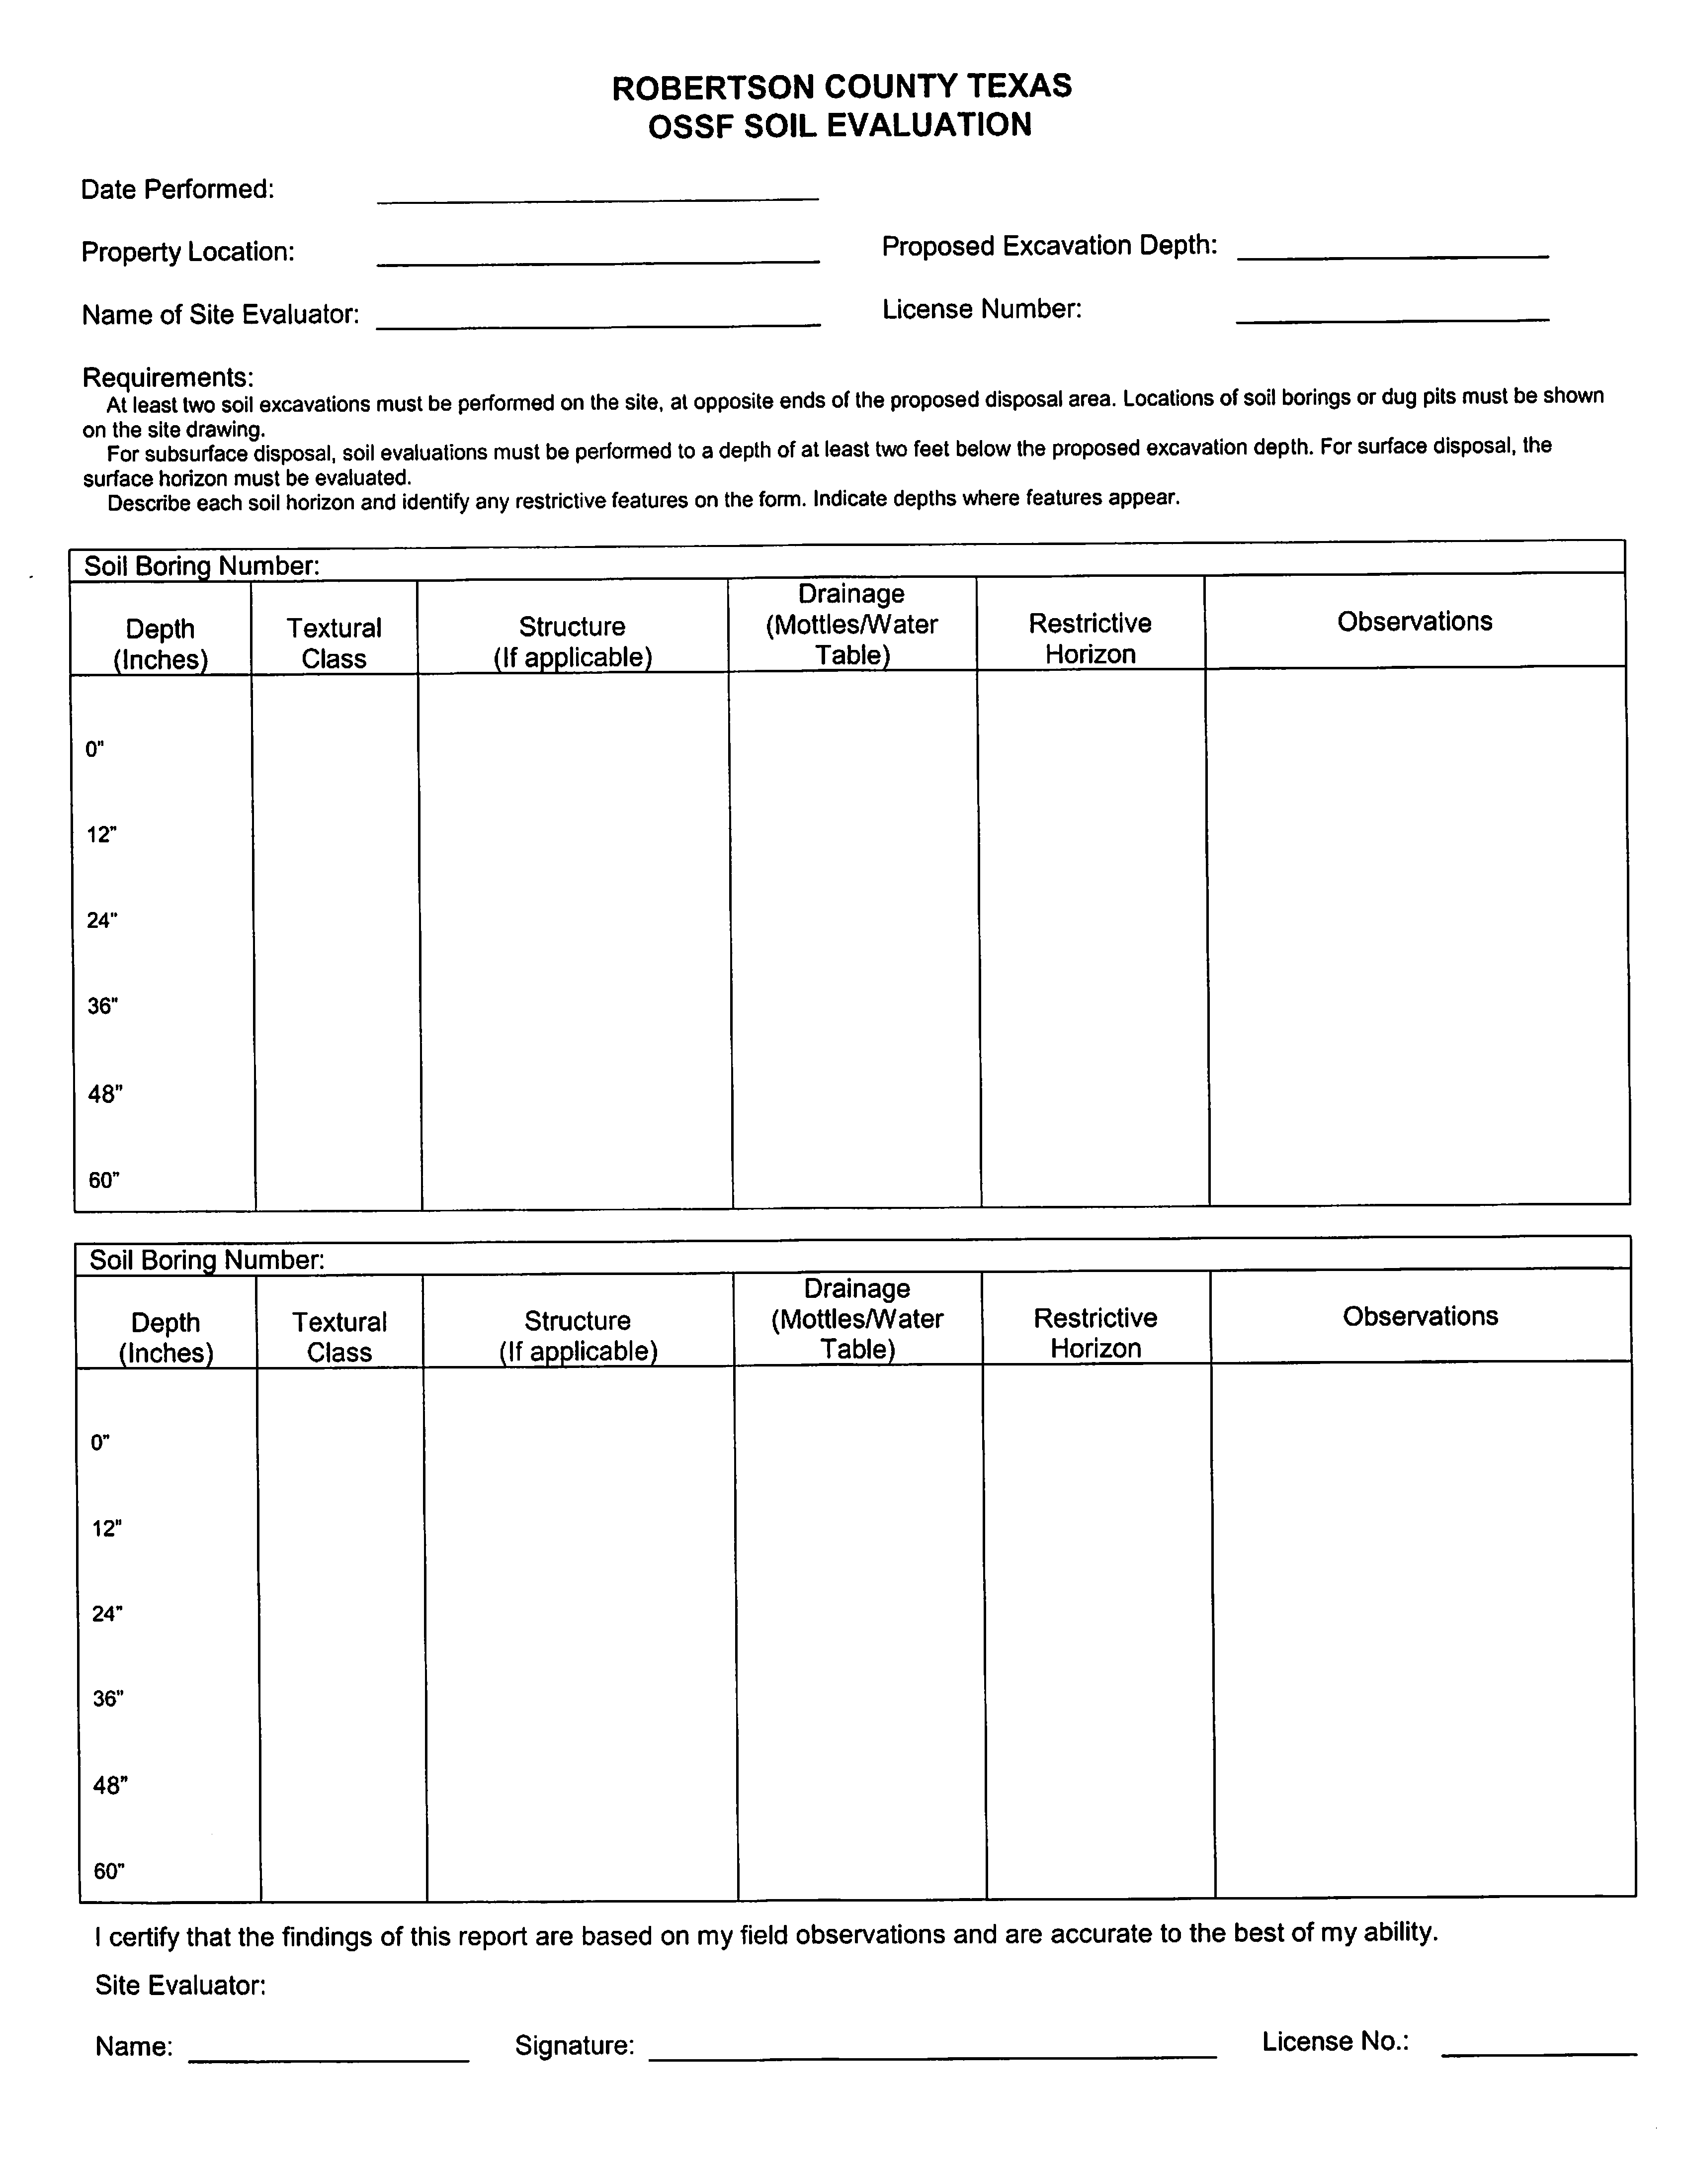

**AFFIDAVIT TO THE PUBLIC**

**THE COUNTY OF ROBERTSON**

**STATE OF TEXAS**

**CERTIFICATION OF ON-SITE SEWAGE FACILITY (OSSF) MAINTENANCE**

According to the Texas Commission on Environmental Quality Rules for On-Site Sewage Facilities, this document is filed in the Deed Records of ROBERTSON County, Texas.

The Texas Health and Safety Code, Chapter 336, authorizes the Texas Commission on Environmental Quality (TCEQ) to regulate on-site sewage facilities (OSSF’s). Additionally, the Texas Water Code (TWC) 5.012 and 5.013, gives the TCEQ primary responsibility for implementing the laws of the State of Texas relating to water and adopting rules necessary to carry out its power and duties under the TWC. The TCEQ, under the authority of the TWC and the Texas Health and Safety Code, requires owners to provide notice to the public that certain types of OSSF’s are located on specific pieces of property. To achieve this notice, the TCEQ requires a deed recording. Additionally, the owner must provide proof of the recording to the OSSF permitting authority. This deed certification is not a representation or warranty by the TCEQ of the suitability of this OSSF, nor does it constitute any guarantee by the TCEQ that the appropriate OSSF was installed.

An OSSF requiring a maintenance contract, according to Title 30, Texas Administrative Code 285.91(12) will be installed on the property described as:

Address at Site: ______________________________________________________________________________________

Legal Description: ________________________________________________________________________________________

_______________________________________________________________________________________________________

The property is owned by: _________________________________________________________________________________

(Please Print)

This OSSF must be covered by a continuous maintenance contract. The undersigned further understands that the owner of the surface application system shall continuously maintain a signed written contract, for service and repairs, with a valid maintenance company. An approved maintenance company must perform all maintenance on the OSSF, and a signed maintenance contract must be submitted to the ROBERTSON COUNTY AUTHORIZED AGENT within thirty (30) days after the property has been transferred.

The owner will, upon any sale or transfer of the above-described property, request a transfer of the permit for the OSSF to the buyer or new owner. A copy of the planning material can be obtained from the Robertson County Health Department.

WITNESS BY HAND(S) ON THIS ___________ DAY OF _________________________________________, ________________.

Signature of Owners ___________________________________________

__________________________________________

SWORN TO AD SUBSCRIBED TO ME ON THIS ____________ DAY OF ______________________________, _______________.

BY: ______________________________________________________

(Printed Name of Homeowners)

_______________________________________

Notary Public, State of Texas

Printed Name: ________________________________________________

My Commission Expires:_________________________________________